CONTINUOUS ASSESSMENT TEST I
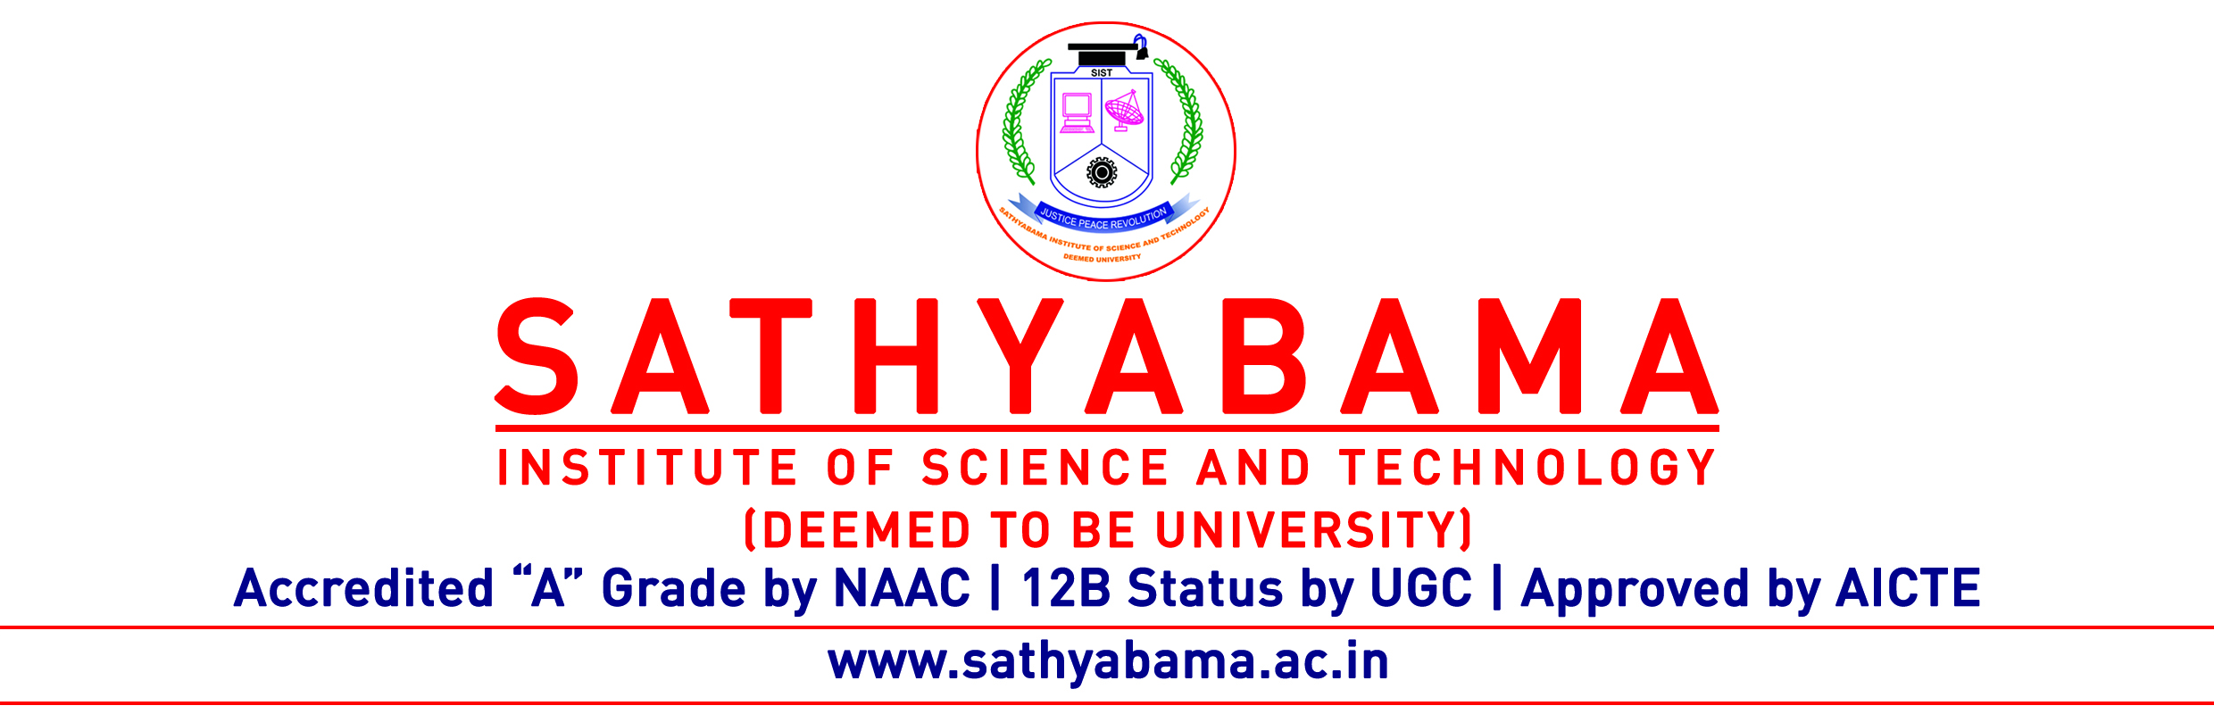
Program : B.E-CSE/IT Max.Marks : 30
Course : Cloud Computing Time : 1 Hour
Course Code : SIT1304 Sem : VI
Batch : 2018-2022 Date: 23/03/2021
Part-A Answer ALL the questions (5×2=10)

Q.No | Questions | CO (L)
 | Define cloud computing model | 1(1)
 | Illustrate on community cloud model | 1(2)
 | Point out the difficulties in public cloud architecture | 1(4)
 | Distinguish between software as a service( SaaS )and platform as a service (PaaS ) models | 2(4)
 | Judge the advantages of using Service Oriented Architecture (SOA) | 2(5)

Part-B Answer ALL the questions (2×10=20)

Q.No | Questions | CO (L)
 | Illustrate on various cloud deployment models. | 1(2)
 | (OR)
 | Explain in detail about advantages and challenges of cloud computing. | 1(3)

 | Assess the benefits and challenges of using Infrastructure as a Service(IaaS) model | 2(5)
 | (OR)
 | Elaborate on the benefits and challenges of using Service Oriented Architecture (SOA) model | 2(6)

